Local Capacity Strengthening for Response Project (LCS4R)
BRANDING AND MESSAGING EXERCISE
Exploring your Organization’s Brand
WHAT TO KNOW: In a crowded landscape of causes, organizations must declare their unique position so they can break free from the clutter and clearly define their brand to their various stakeholders.
WHAT TO DO: Please answer the following questions for your organization, and use the International Medical Corps example, below, as a guide:
A brand promise is a value or experience an organization’s stakeholders can expect to consistently receive when they interact with the organization. What is your brand promise?
Your response:

A brand differentiator is a unique feature, aspect, and/or benefit of your work and services that sets it apart from similar, often competing organizations. What are your brand differentiators?
Your response:

Brand positioning describes how a brand is different from its competitors and where, or how, it sits in stakeholder’s estimation. What is your brand positioning?
Your response:

Why should a donor choose your organization? Why does it matter? Why now? Why?
Your response:

A call to action (CTA) is a marketing term that refers to the next step or action that the organization wants its audience members to take. CTAs can be as direct as a button to click or include actions such as ENGAGE, ADVOCATE, SHARE, DONATE, SIGN-UP, etc. What are your calls to action?
Your response:

EXAMPLE: International Medical Corps’ First Responder Brand Development
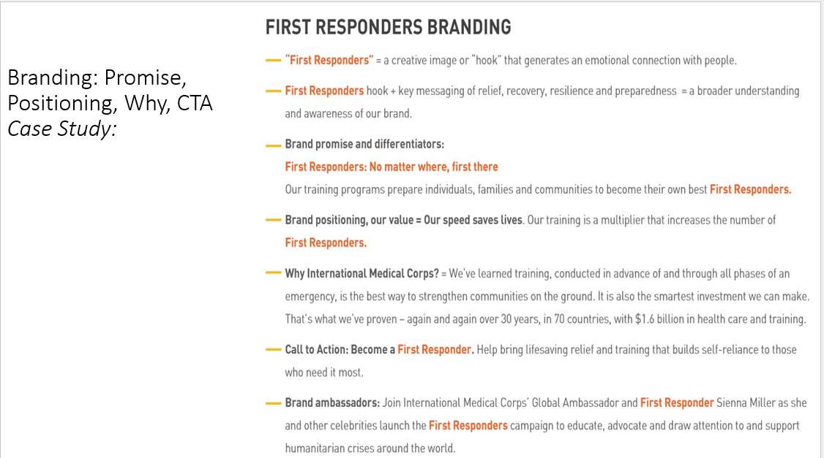

Exploring your Organization’s Key Messages
WHAT TO KNOW:
- Key messages are the main points of information you want your external audience to hear, understand, and remember.
- The messages are bite-sized statements that articulate what you do, why you do it, how you are different, and what value you bring to your stakeholders. They are simple, engaging, memorable and easy for staff and stakeholders to repeat and share with others.
- It is best to begin with 3 key messages aimed at a broad group of stakeholders. (Later, additional messaging can be tailored to specific audiences.)

WHAT TO KNOW: Draft Your 3 Key Messages
What are the 3 most important things you would like your stakeholders (broadest audience) to know about your organization? (Know your audience: It’s helpful to also consider what your stakeholders would like to know.)
Your response:
Message #1: (For example: What you do)

Message #2: (For example: How do you do it and the value of that approach)

Message #3: (Why it matters and why donors should choose you)

